**Part 1: Understanding SQL (30 minutes)**

**Question 1. Research**

Use online resources like websites or PowerPoint slides.

**1.1. In a single Word document, summarize your findings in a short paragraph (3-5 sentences). Web Applications:**

Imagine a dynamic website like an online store. How do you think SQL plays a role in managing data behind the scenes? Consider how product information, user accounts, and order details might be stored and accessed.

* SQL is being used by online stores to create data, retrieve data, store data and manipulate data.
* Product information: The products are stored in tables where the columns are the attributes. The data here is accessed using SQL queries where you can retrieve, insert and delete product information.
* User accounts: The user accounts are stored in tables and to access it using SQL queries for updates and user authentication.
* Order details: Orders are stored also in a number tables to be able to handle a number of items in a single order. Access is done with SQL queries to e able to create, update and retrieve orders.

**1.2.** Write a short explanation (3-5 sentences) in your document about the role of SQL in web applications.

* The role of SQL being implemented on web application is to help in designing a database that will assist in managing of data, report generation, ensuring there is proper security and data integrity. It is crucial for creating dependable and scalable web applications because of the way it interacts with backend technologies to facilitate effective data handling and storing.

**1.3.** List 3 benefits of using SQL for web applications.

* Efficient data management.
* Data Integrity.
* Transaction management.

**1.4.** Think about efficiency, data organization, and data retrieval capabilities. Briefly explain each benefit in your document (1-2 sentences per benefit).

* Efficiency: The storage of data in a structured format in the database is done using tables with rows and columns.
* Data organization: The data is highly organized in a structured way; this makes it easy to search and analyse.
* Data retrieval: Sophisticated data retrieval is made possible by SQL's ability to support complicated queries using JOINs, subqueries, and different clauses (such WHERE, GROUP BY, and ORDER BY).

**1.5.** List any 3 Database Management Systems.

1. MySQL 2. PostgreSQL 3. Microsoft SQL Server

**Part 2: Database Fundamentals (45 minutes)**

**Question 2.1: Tables**

Think about how data is organized in rows and columns. In your document, define a database table and explain its similarity to a spreadsheet (2-3 sentences).

* A database table is a structured set of data organized in rows and columns, where each row represents a record and each column represents an attribute of the record. It is similar to a spreadsheet since both use a tabular format to organize and display data, making it easy to read, manage, and perform operations on the data.

**Question 2.2: Columns**

Consider different types of data like text, numbers, and dates. Define "columns" and provide an example with an explanation (2-3 sentences) in your document. Data Types: Why are data types important in a database? Briefly explain 3 common data types (e.g., Text, Number, Date).

* Column: represents a specific attribute of the data stored in the table.

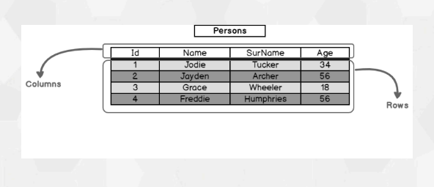

* Data types in SQL are critical for assuring data integrity, optimizing storage, improving performance, maintaining consistency, and utilizing built-in functions and operations.
* Types of data types include: String (CHAR, VARCHAR), numeric (INT), date & time (DATE, TIME), Json data types

**Question 2.3: Data Types**

Think about how data types ensure data integrity and efficient storage. Explain the importance of data types and provide brief explanations of 3 common types (2-3 sentences each) in your document.

* The importance od Data types is to ensure uniform data handling and easy interpretation on the database. Make it easy when querying the database thus enhancing performance. Storage efficiency since different data types require different storage space.
* Common types of data types include:

1. INT: This is an integer
2. CHAR: This is a character.
3. DATE: This is used to display date in the format of YYYY-MM-DD

**Part 3: Expense Tracker Database Design (45 minutes)**

**3.1. Planning**

We'll be building an Expense Tracker application. What kind of data do you think we'll need to track? List at least 5 data points relevant to our project. Consider information like expense amount, date, and category. List your identified data points in your document.

* Data that is relevant to our Expense Tracker project include: User information, income, expense, recurring expense, payment method, budget, date, category.

**3.2. Tables**

Considering the data points you listed, design a basic database schema with one main table (likely named "Expenses"). Define the columns needed for this table. Assign appropriate data types to each column based on the kind of data it will hold. (e.g., amount: number, date: date, category: text)

* CREATE TABLE users ( user_id INT PRIMARY KEY, username VARCHAR(50) NOT NULL, email VARCHAR(100) UNIQUE, created_at TIMESTAMP DEFAULT CURRENT_TIMESTAMP );
* CREATE TABLE Expenses ( expense_id INT PRIMARY KEY, amount DECIMAL(10, 2) NOT NULL, date DATE NOT NULL, category VARCHAR(100) );

**Bonus:**

Sketch a simple Entity Relational Diagram (ERD) of your table structure, including column names and data types.

Use drawing software or a simple table format to visually represent your schema.

